**EXPERIMENT NO : 1**

**UID : 23016017**

**NAME : AAYUSH DUBEY .**

**AIM :CASE STUDY NON LIBRARY MANAGEMENT SYSTEM .**

**SDLC: A Blueprint for Software Development**

**SDLC**, or Software Development Life Cycle, is a structured process that outlines the steps involved in creating high-quality software. It's like a roadmap that guides development teams from the initial concept to the final product and beyond.

**Key Phases of SDLC**

While the exact phases can vary depending on the specific methodology used, the general SDLC process typically includes the following steps:

1. **Planning and Requirement Analysis:**
   * Identifying the software's purpose and target audience.
   * Gathering and documenting requirements from stakeholders.
   * Feasibility studies and project planning.

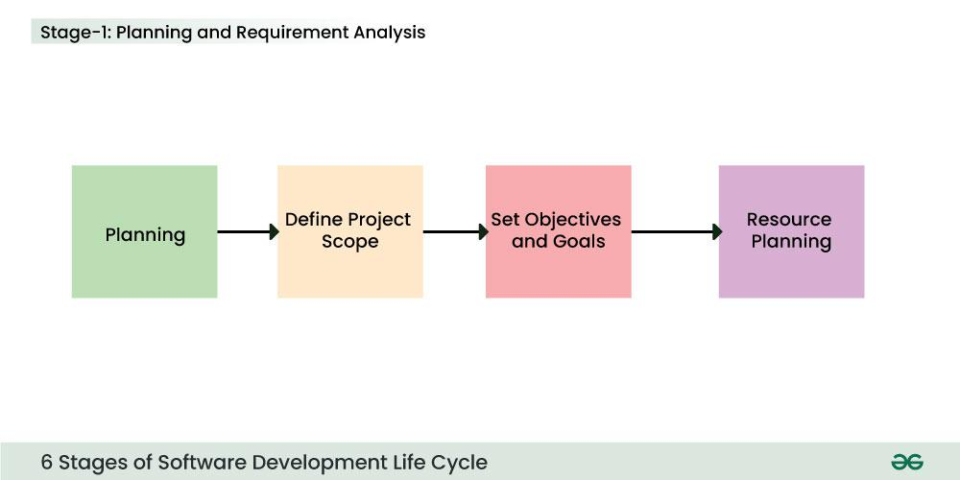

**2. Defining Requirements:**

* + Creating the software architecture and blueprint.
  + Defining system components, interfaces, and data flow.
  + User interface (UI) and user experience (UX) design.

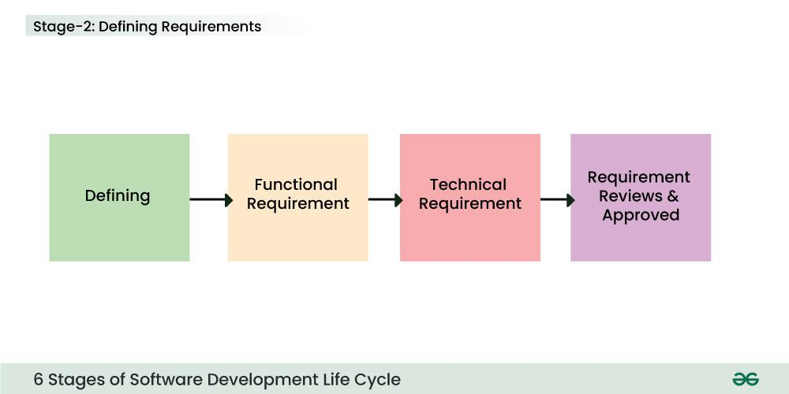

1. **Design:**
   1. Writing the actual code based on the design specifications.
   2. Selecting programming languages and tools.
   3. Building the software components.
   4. 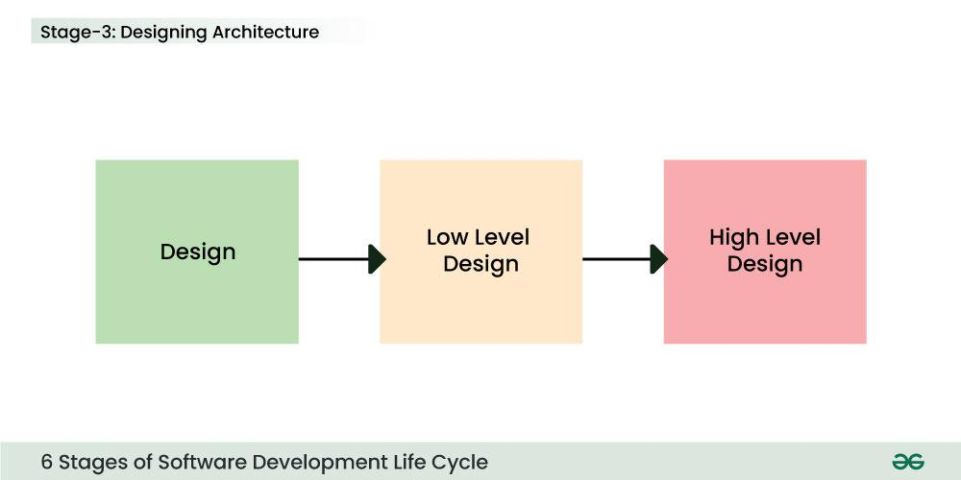
2. **DEVELOPMENT:**
   1. Identifying and fixing bugs and errors.
   2. Ensuring the software meets the specified requirements.
   3. Different types of testing (unit, integration, system, acceptance). 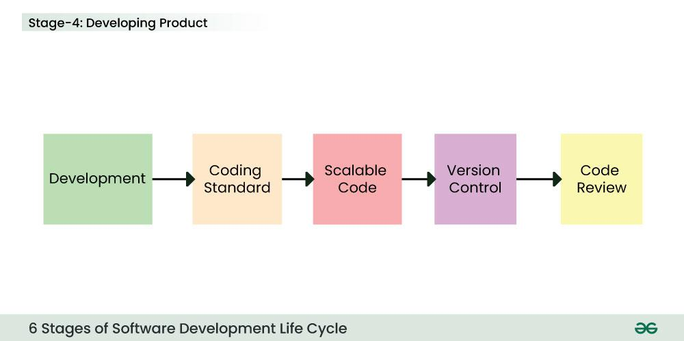
3. **Testing :**
   1. Releasing the software to the market or end-users.
   2. Installation and configuration.
   3. User training and support. 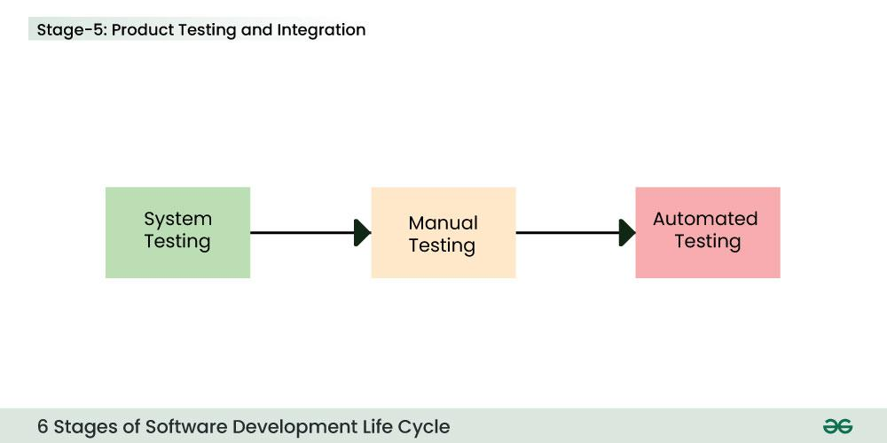
4. DEVELOPMENT AND MAINTENCE :

Fixing bugs and issues reported by users.

* 1. Adding new features and enhancements. 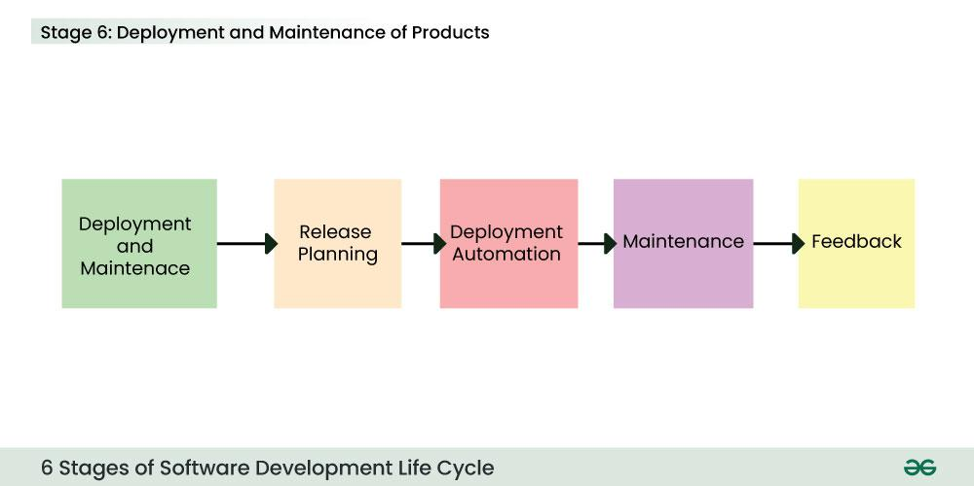

**Specific Benefits of Library Management Systems (LMS) :**

* **Centralized management:** Manages multiple library branches efficiently.
* **Cataloging and classification:** Standardizes cataloging processes and improves search accuracy.
* **Circulation management:** Tracks book loans, renewals, and returns accurately.
* **User management:** Manages patron records and access privileges.
* **Reporting and analytics:** Generates reports on library usage and performance.
* **Integration with other systems:** Connects with other campus systems for seamless data exchange.

MY CASE STUDY ON DEVELOPING A BUS SERVER NETWORK :

**Case Study: Developing a Bus Server Website for a College Using SDLC**

This case study will explore the development of a bus server website for a college using the Software Development Life Cycle (SDLC). We will follow the Waterfall model, a linear sequential process with clear phases, to illustrate the process.

**SDLC Stages**

**1. Planning and Requirement Analysis:**

* **Identify stakeholders:** The primary stakeholders for this project are the college administration, students, and faculty.
* **Gather requirements:** The requirements for the bus server website include:
  + **Basic functionality:** Users should be able to view bus schedules, book seats, and track bus locations.
  + **User interface:** The website should be user-friendly and easy to navigate.
  + **Security:** The website should be secure and protect user data.
  + **Accessibility:** The website should be accessible to users with disabilities.
* **Feasibility study:** A feasibility study is conducted to determine the project's viability and identify potential risks.
* **Project plan:** A project plan is created, outlining the project scope, timeline, budget, and resources.

**2. Design:**

* **System architecture:** The system architecture is designed, including the database schema, user interface, and server infrastructure.
* **Database design:** The database is designed to store bus schedules, seat availability, and user information.
* **User interface design:** The user interface is designed to be user-friendly and intuitive.
* **Security design:** The security measures are designed to protect user data and prevent unauthorized access.

**3. Development:**

* **Coding:** The website is developed using HTML, CSS, JavaScript, and a backend programming language such as PHP or Python.
* **Database implementation:** The database is implemented to store bus schedules, seat availability, and user information.
* **User interface development:** The user interface is developed to be user-friendly and intuitive.
* **Security implementation:** The security measures are implemented to protect user data and prevent unauthorized access.

**4. Testing:**

* **Unit testing:** The individual components of the website are tested to ensure they function correctly.
* **Integration testing:** The different components of the website are tested to ensure they work together seamlessly.
* **System testing:** The entire website is tested to ensure it meets the requirements and functions as expected.
* **User acceptance testing:** The website is tested by end-users to ensure it meets their needs and expectations.

**5. Deployment:**

* **Deployment:** The website is deployed to the college's server.
* **User training:** Users are trained on how to use the website.
* **Support:** Support is provided to users for any issues or questions.

**6. Maintenance:**

* **Updates:** The website is updated with new features and bug fixes.
* **Security patches:** Security patches are applied to protect the website from vulnerabilities.
* **Monitoring:** The website is monitored for performance and security issues.

**Conclusion :**

In conclusion, we now know that the **Software Development Life Cycle (SDLC) in software engineering is an important framework for the better and more structured development of optimized software programs.** In a world full of rapid evolution in technology, SDLC phases plays a crucial role in enabling some good and innovative solutions for helping users and organizations. Also, it’s better to adapt SDLC principles to achieve software development goals effectively.